Hello Walden Homeowners. Attended my second class given by Colorado State University on Drip Irrigation Systems and have summarized my notes to share with all of you. Spring is on its way and those of you who have had their irrigation system “blown out” should now be thinking about starting them up in April. True, the fickle Colorado weather could (and usually does) surprise us in April, but as we move past the Spring Equinox (March 20th) our temperatures are higher, the snows are wetter, and recovery to warmer weather is faster. Once again what we will cover here goes a little beyond the norm, but is key to healthy plants with deep root systems.
Our Environment
Our Walden homes reside in a semi-arid, desert like, part of Colorado. We average between 12” to 15” of rainfall during the summer. Some seasons are wetter, and some are drier. Most of the Colorado Front Range experiences the same type of weather pattern as Walden. This is why Drip Irrigation systems are key to Landscape and Xeriscaping yard designs. But let’s keep in mind that our water is expensive, and conservation is important. Our goal is to have a healthy, beautiful Landscape plan around our homes, yet not break our budget to do it.
Types of Irrigation Devices and their Efficiencies
Basically we use two types of water emitters. One is Overhead Irrigation, which we commonly see as our “pop up” sprinkler systems. These devices are designed to cover a large area of our yards and are good for lawns. Yet as good as they are, their efficiency (putting water on the ground) is only 50% to 70% due to our low humidity. Many of us run our systems at night to avoid the daytime evaporation factor, around 10 to 11pm allowing the water to soak into the soil. But we still waste 30% to 50% of our water.
Drip Irrigation on the other hand has a 90% efficiency rating since it is already installed on or under the soil, has direct contact with the plant or shrub, and its delivery is slow and low. Another advantage to drip systems is that it helps keep the plant healthy and strong thus avoiding some diseases. Also weed germination is curtailed since the seed is deprived of moisture. Drip systems are also excellent to maintain plant containers, removing the daily watering tasks.
But like all systems there are the normal disadvantages. Leaks, breaks, and clogging are the usual culprits. Those symptoms are usually invisible to the homeowner so they can be difficult to find. That is why it is important to keep an Irrigation Map so one can easily troubleshoot those issues. Another is sun or winter damage to exposed emitters. Even though the sprinkler head “pops up”, the parts in direct contact with the sun or cold are “baked” or “frozen” to the point of failure. Emitters covered by a grass or mulch are better protected from the elements.
Installing or adding to a Drip Irrigation System
There are a couple of ways to install Drip Irrigation. One is to hire a professional, and the other is the do-it-yourselfer. Professional installation is expensive, but you have a guarantee and someone else does the work. But when one gets to the position of adding another zone and valve to the valve box, that may be best put in the hands of a professional. We also have many great do-it-yourselfers here in the Walden community who are quite talented, can do this job easily, and give advice.
Now existing Drip Systems are not complicated, and adding another line relatively simple. Here is an example. First, clear your area of mulch. Then cut the line. For a ½” tube, just use a ½ “ ‘T’ connector. Next, install the ‘T’ connector. Now install the ½” main line to your ‘T’ and run the line to your to your new site. Add the emitters to your ½” line. Then run drip lines from the emitters to your plant. Cover the lines and you are done. If you are watering an incline, position the drip lines downhill from you main tube so gravity will assist your watering.
But how many emitters can you put on one line? There is an easy test to find that out. First get a 5 gallon bucket (a Home Depot bucket will work). Then get a stopwatch, a watch with a second hand, or a digital watch. Start your timer mark and simultaneously turn on the water from the hose bib (aka sillcock) and fill the bucket. Time how long it takes the bucket to fill. Now here is where the math comes into play.
Take the bucket size (say 5 gal) and divide the size by the time it took to fill it. So 5 gal divided by let’s say 50 seconds and we get 0.1 flow for 50 seconds. Now there are 3,600 seconds in an hour, so multiply the 0.1 number by 3,600 and you get a flow of 360 gallons per hour (GPH). Ready for the next step?
OK now let’s find out the adjusted flow for our ½” tubing. To do that we take our 360 GPH number and multiply it by .75, which is the adjusted flow for ½” tubing. We get a result of 275 GPH.
Now we are ready to figure out the number of emitters we can add to our line. First take our 275 GPH result and divide it by the GPH flow for the emitter. So a 1 GPH flow would result in 275 emitters. And a 2 GPH emitter would result in 137 emitters. For existing systems you will need to know how many emitters are already installed, then subtract them from your number. If you don’t know, do a worst case guess. For new zones, this math will work out fine.
Here is one hint that will help you. If possible, try to use a common emitter for each zone, like a 1 GPH. This way it is easier to adjust their watering times and flow.
Emitters and Sprayers
We have expensive water in Walden as attested by our summer water bills, so conservation is key to healthy plants and a low water bill. Drip Emitters can help you control some of that water bill yet keep your landscape healthy.
First, they recommend you do not to mix drip emitters and sprayers on the same line. I have done this because todays sprayers have a flow control whereby you can ‘tune’ the spray to the need of the plant. But keep in mind that the greater radius you spray, the less pressure in the line, and thus the less efficient the emitters will water your other plants.
Emitters can be attached to the main tube, or placed at the end of your drip tube. When you attach the emitter to the main tube, you cover the device with soil and/or mulch thereby protecting it from the sun
and cold. When you attach the emitter to the end of the drip line, it is placed on the edge or in the center of the plant, exposing it to the elements. Also when you attach the emitter to the main line, you require one less part. Either way will work.
Emitters come in a wide variety of flow rates and are measured by Gallons Per Hour (GPH). Common emitters are ½, 1, 2, and 4 GPH but can go as high is 24 GPH. I typically use 1-2 GPH emitters. If you are planting flowers, and have a clay soil starting 6” below the soil surface, a 1 GPH emitter would be a good starting point. This is due to the variable soil density. Clay soil will absorb moisture slower, so you want to prevent any overflow the plant does not use from laying on the bottom of the root ball and potentially creating a moisture fungus that can eventually destroy the plant.
Soils are also relative to emitter choice. If you have a sandy/loamy area (aka large pore in Agriculture terms) your water will penetrate 12” in a space of 15-20 minutes. In contrast, Clay soils will take 2 hours to penetrate 12”. So your timers will need to be set differently depending on soil condition. The best way to evaluate your soil is to dig down 12” and look at the layers. You will find that the soil closer to your home will be more porous because when the foundation was laid for your lower level, much of the fill dirt was topsoil. Further away from your home the soil is not affected much by the construction process so the original layers remain.
What is an Irrigation Loop?
Irrigation loops to do many things. Water a tree, water rows of flowers or shrubs, etc. When used with emitters you maintain much of the line pressure integrity yet provide the necessary moisture flow to all the emitters on the zone. The illustration below shows an example of a “triple loop”. The main line is on the left, and the loops come off the main line.
So if you are landscaping the front of your home, and you have multiple rows of plants, use loops off the main line to meet all of your water needs. (See illustration below)
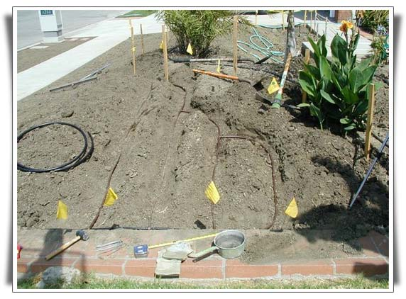
Here is another illustration of a loop you can use to water a tree. The water source is your main line, and the loop comes off as a single line to the tree then “loops” around the tree to provide you multiple points for emitters. If you use 1 GPH emitters in a 4-8 point water plan, you can provide 4-8 gallons of water to the entire tree root structure every watering cycle. Remember, by using emitters, you still maintain much of the line pressure integrity in the zone. This is important, so you do not “starve” other emitters on the line. Note: The ball valves in this illustration are not required.
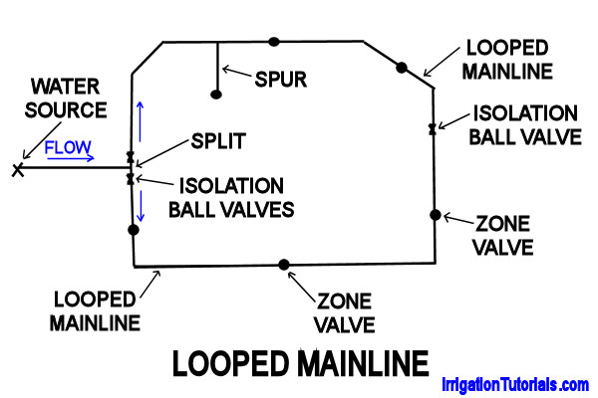
How Much Tube Do I Use?
If you install a new valve to your sprinkler system, you may run as much as 250 ft of ½” tubing from the valve to your site. That is a lot of tubing to work with. Keep in mind if you do not need to run one continuous length of tubing, you can use the “Looping” example in the last section to address those multiple sections of plants.
Also if you want to mix 1 and 2 GPH emitters on a single line, for every 2 GPH emitters you add, remove one of the 1GPH emitters. That way your line will remain in water flow balance.
Closing Comments
* Water deeply and infrequently OR water to adequate depth.
* Winterize your system every year to protect your irrigation components.
* Drip Irrigation systems only require 20-25 lbs of water pressure to run efficiently.
* Keep lines straight. Avoid sharp turns. Use a 90 degree connector to prevent kinks in the line.
* On slopes, use a landscape staple every 3-4 ft to keep line from drooping.
* As plants mature, increase emitter GPH flow to meet the required moisture.

